**Create Windows Server 2012 R2 VM (Azure New Portal)**

**Step 1:** Open Microsoft Azure Portal

<https://portal.azure.com/>

sign in with credentials

**Step 2:** Click on New -> Compute -> Windows Server 2012 R2 Datacenter

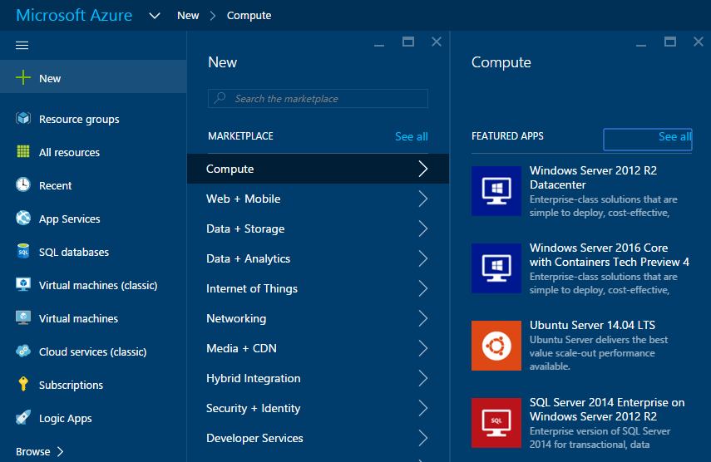

After selecting windows server 2012 R2 Datacenter, Deployment model blade will open.

**Deployment Model: Resource Manager**

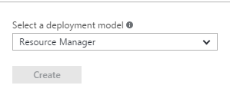

**1.Basics**

Enter Name you want for the Virtual Machine

Enter administrator username & password

Create new resource group or choose existing group

Select Virtual Machine datacenter location

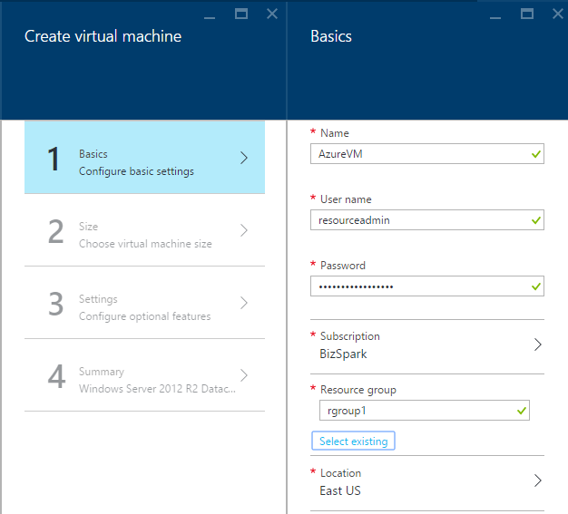

**2. Size**

Select Virtual Machine size according to requirement: Standard or Basic,

A, D, DS, G, GS Series

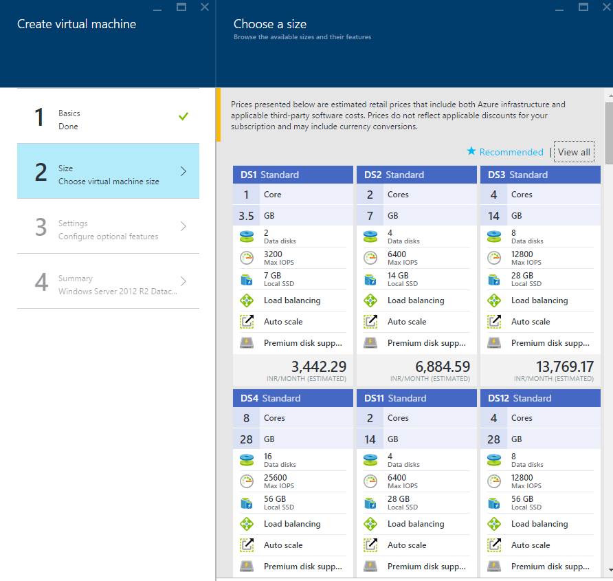

**3.Settings**

This is very important option of Virtual machine with all settings

Ex. Disk Type, storage account for VM, Network, Subnet, Public IP address, Network security group, Monitoring, Availability set, etc

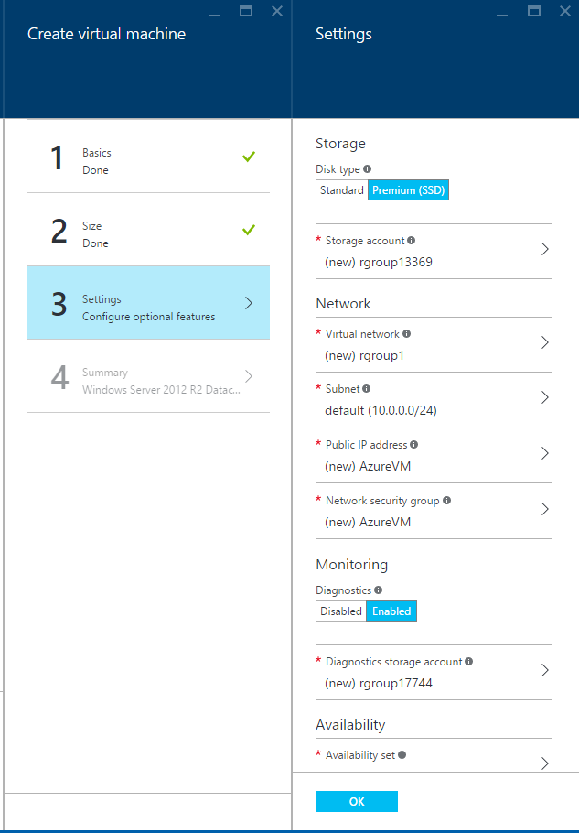

**4.Summary**

Summary blade of virtual machine will open and click on ok button

Wait for few minutes to configure VM

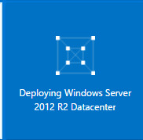

VM settings blade

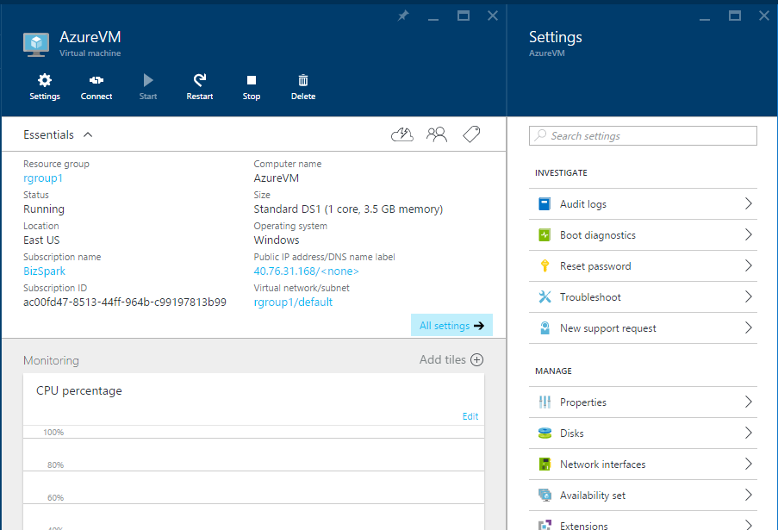

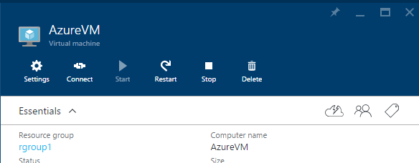

Click on “Connect” option in settings & one .rdp will download



“Connect” button

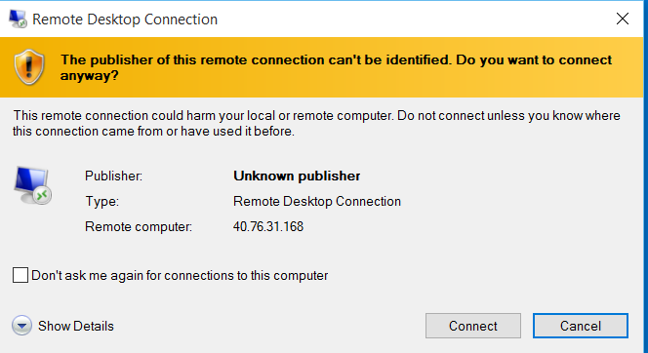

Enter VM username & password. Not VM Name

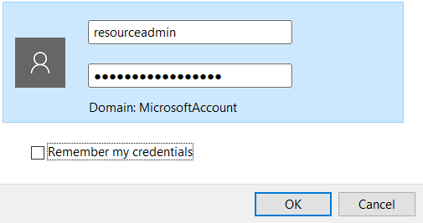

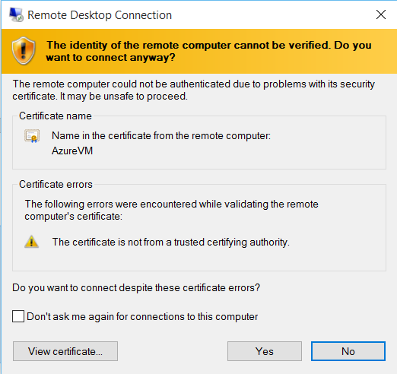

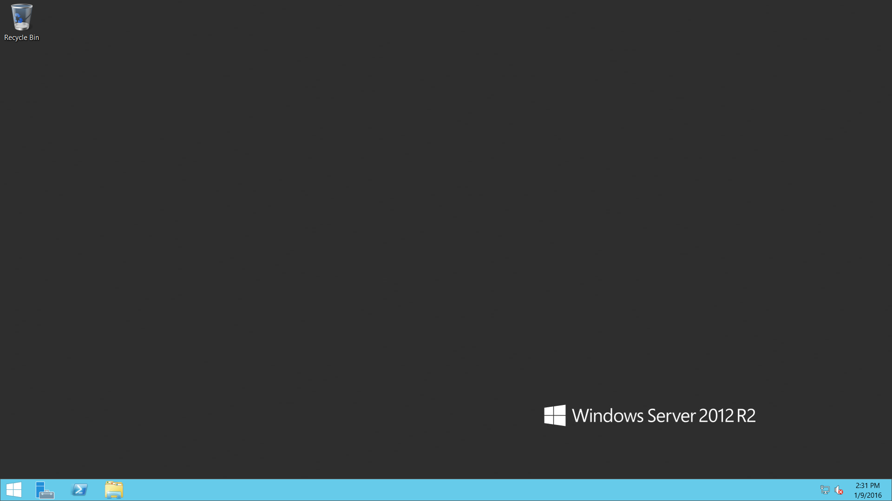

Start Server Manager

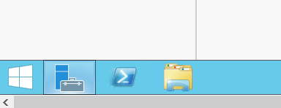

Select “Add roles and features” option

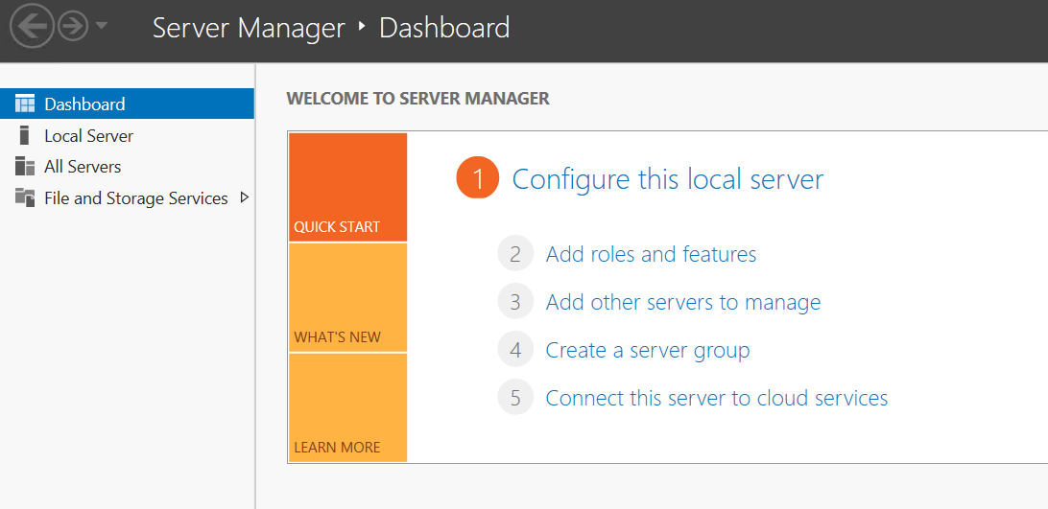

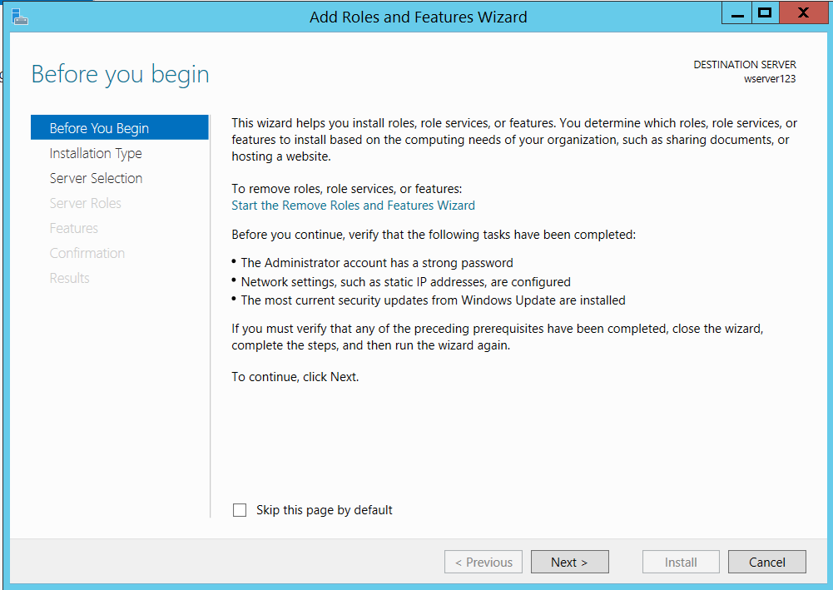

Choose first option “Role-based or feature-based installation”

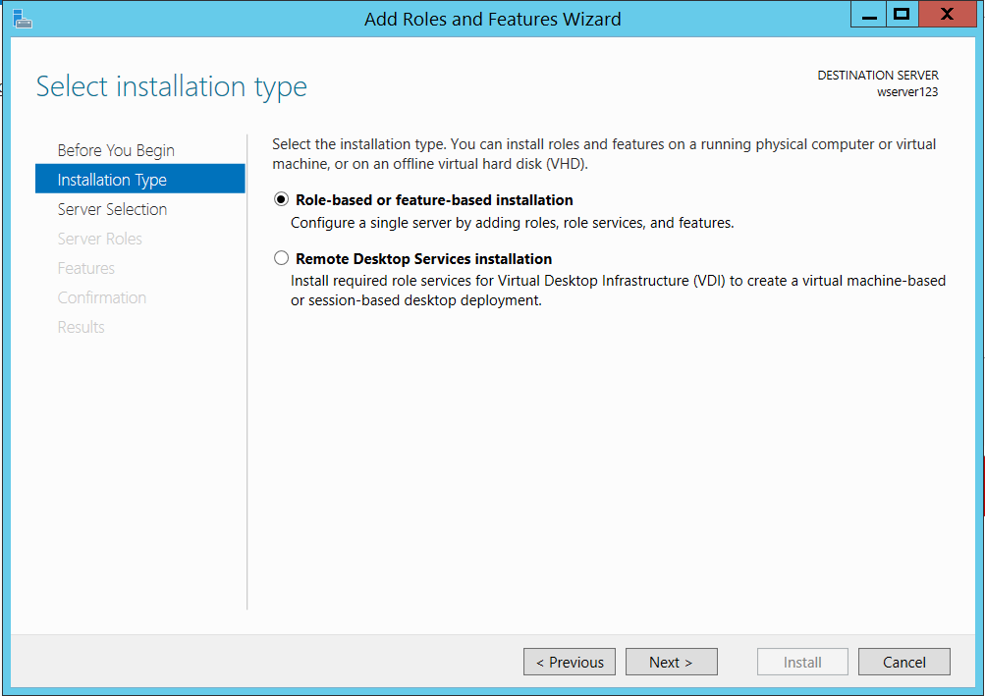

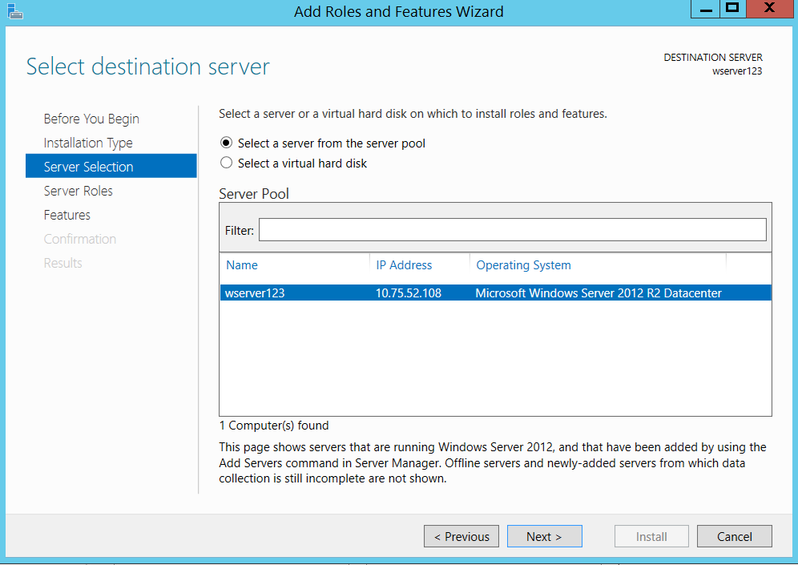

In Server Roles please add “Application Server” & Web Server(IIS)

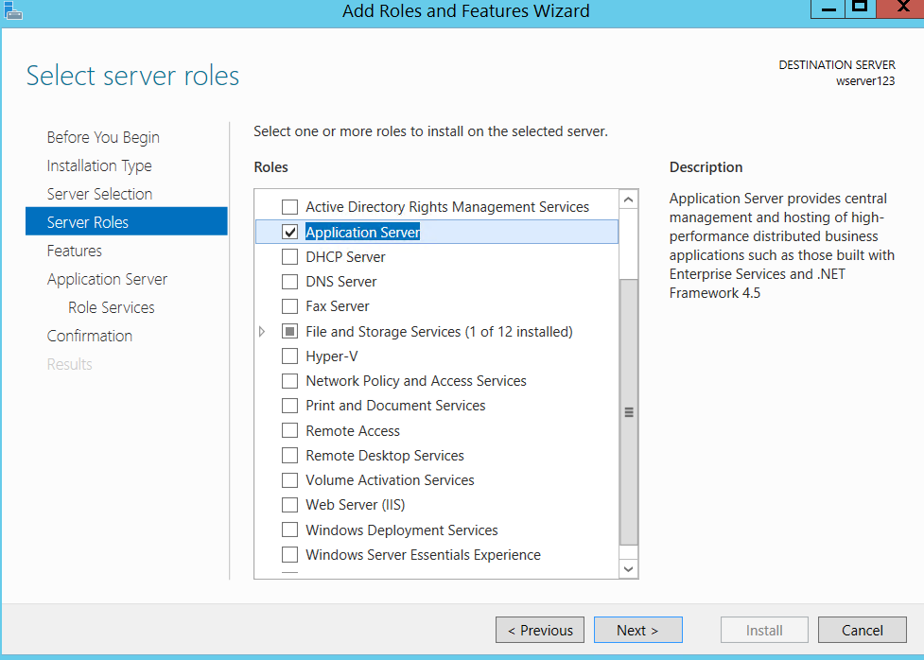

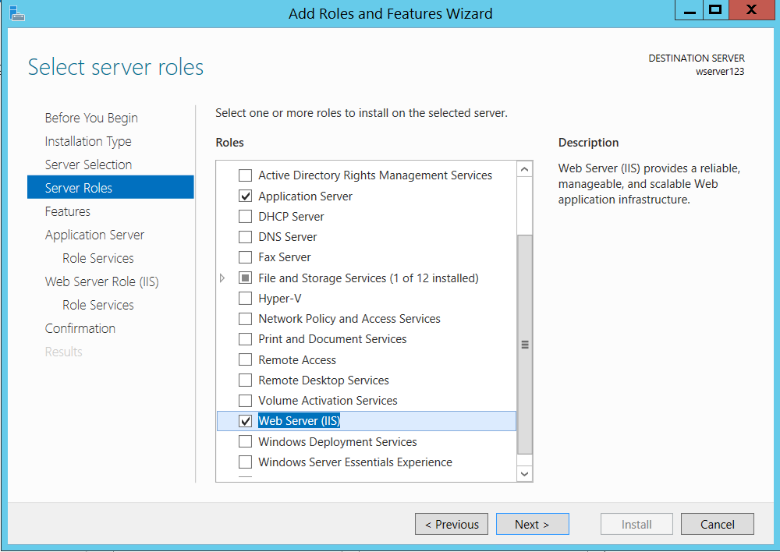

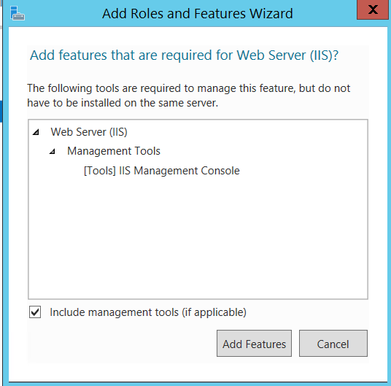

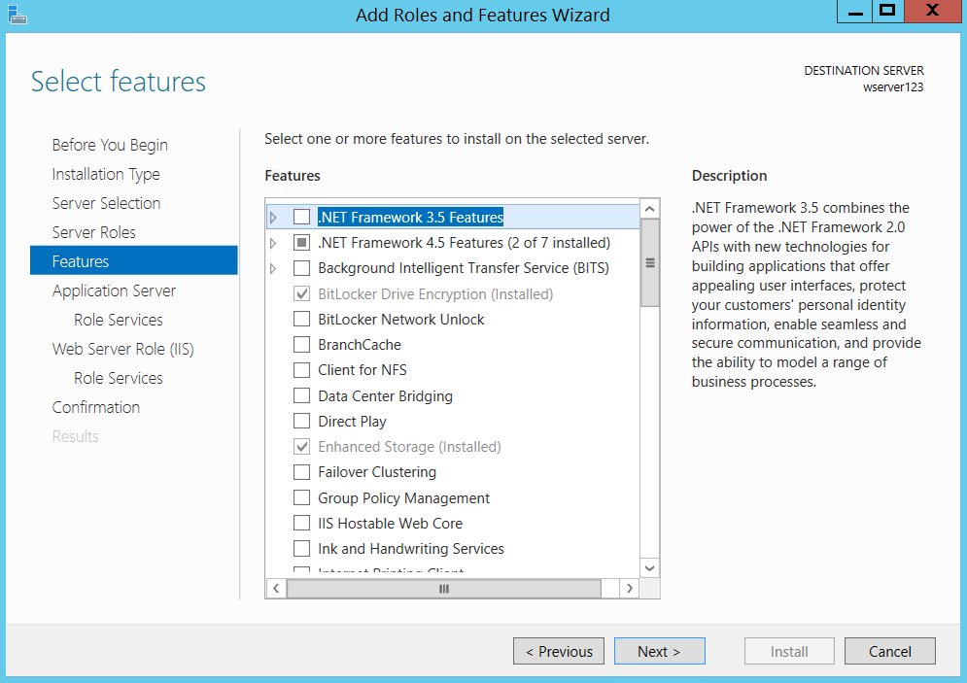

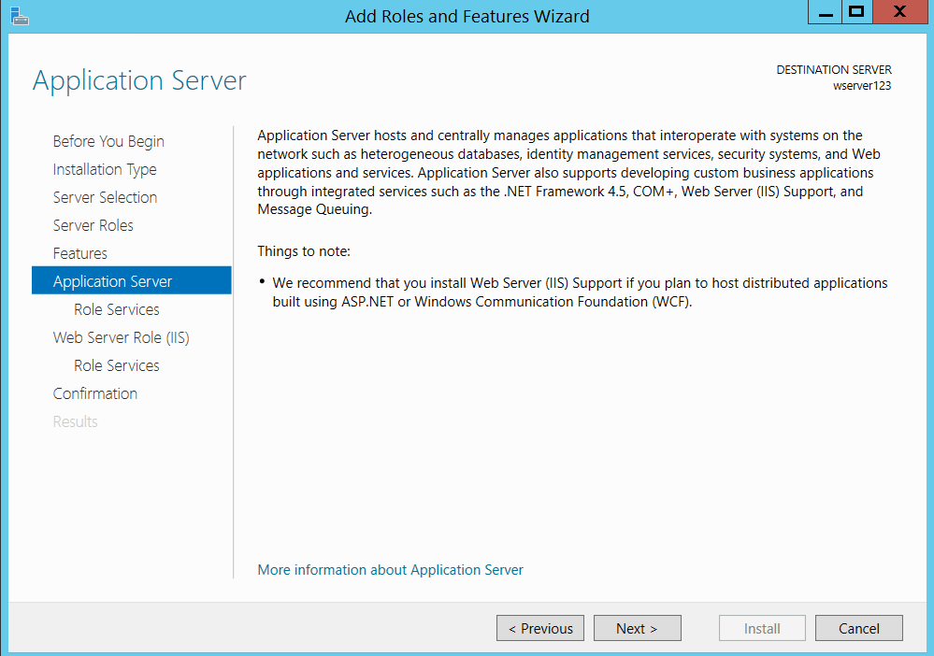

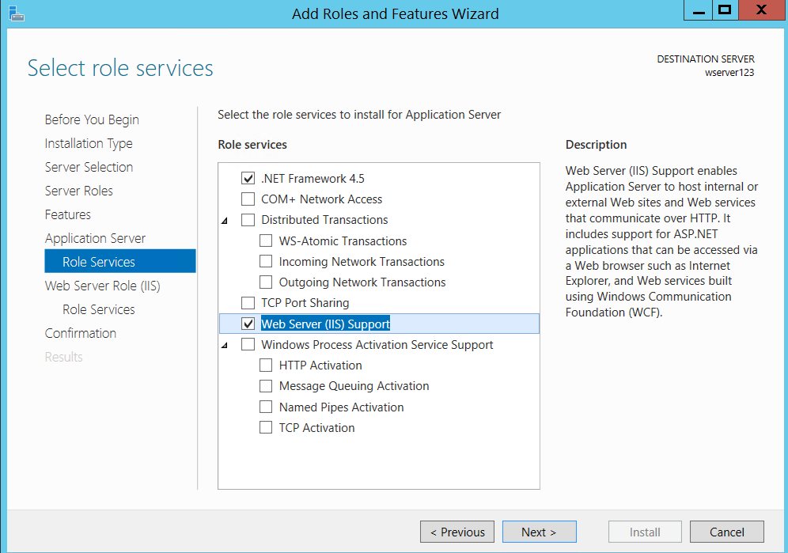

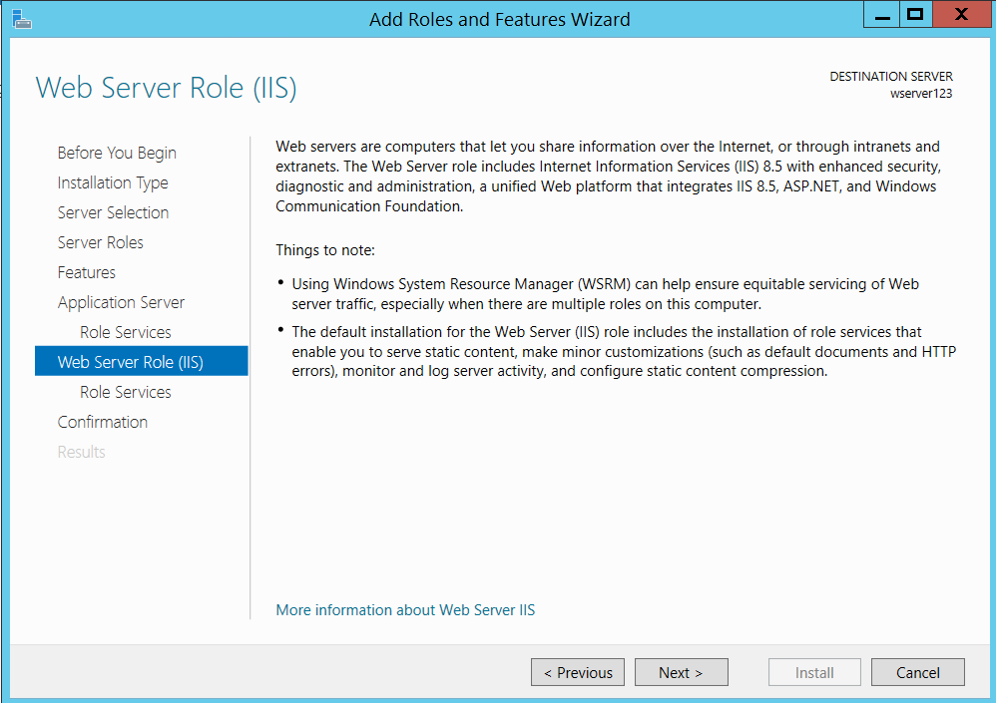

Choose IIS 6 options

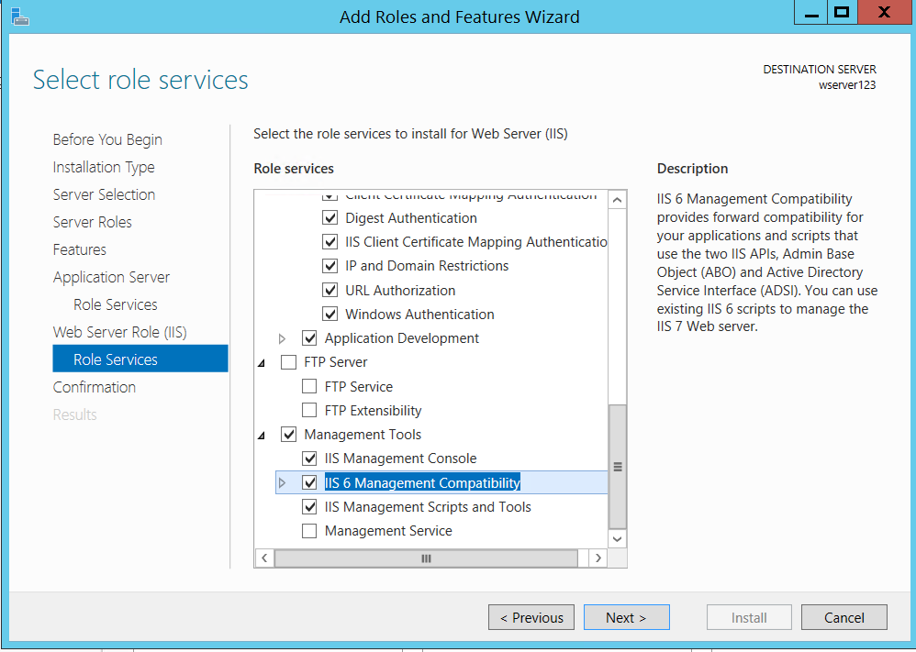

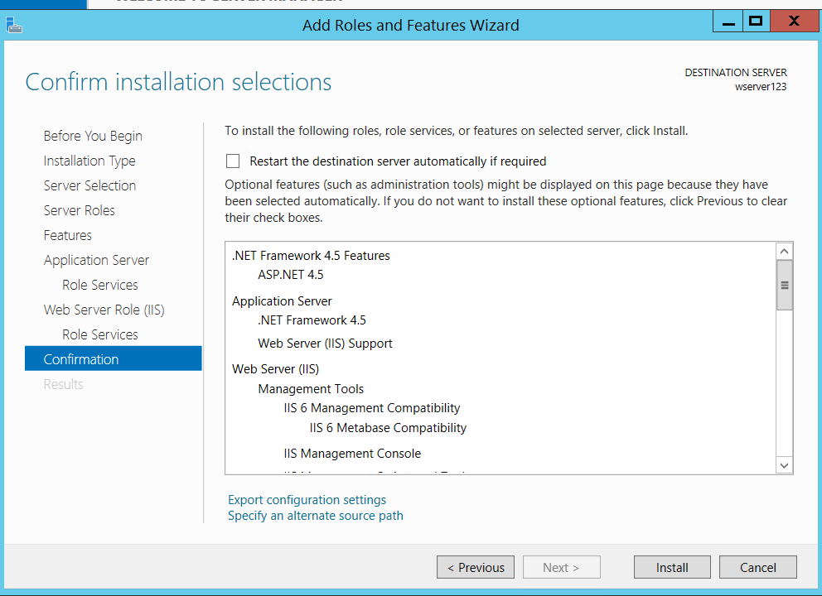

Wait for installation

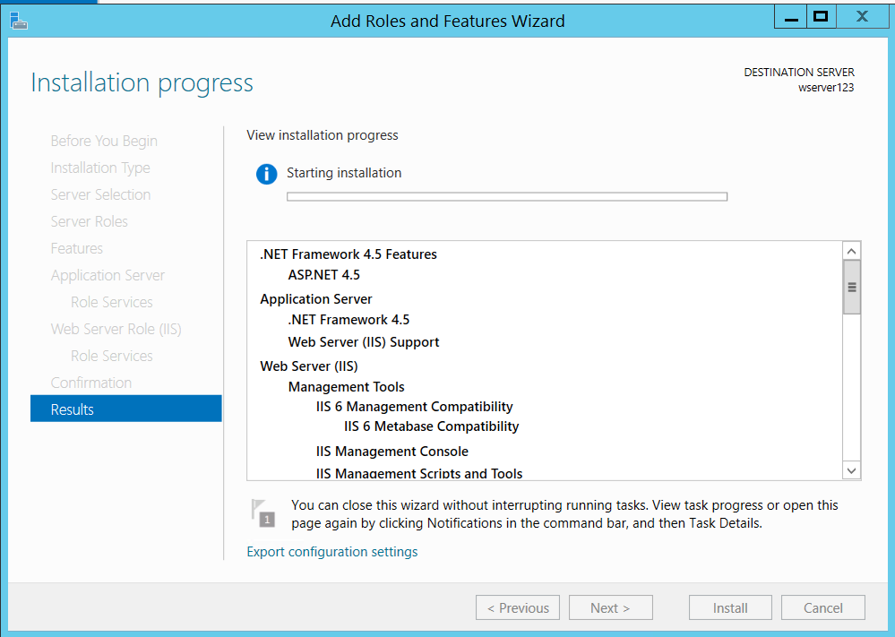

Close the window

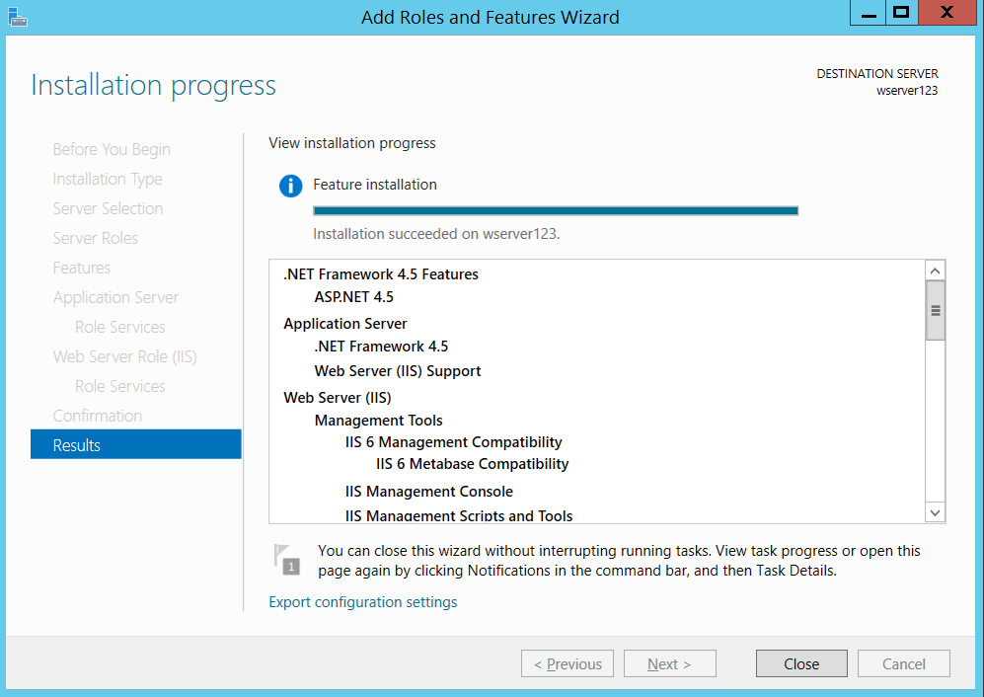

**Navigate to Azure Portal**

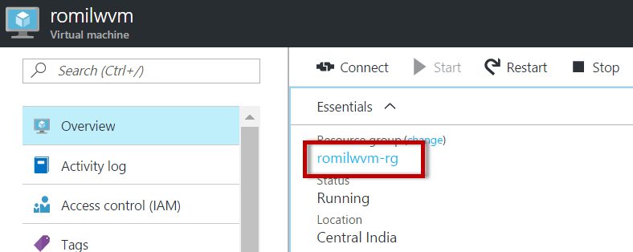

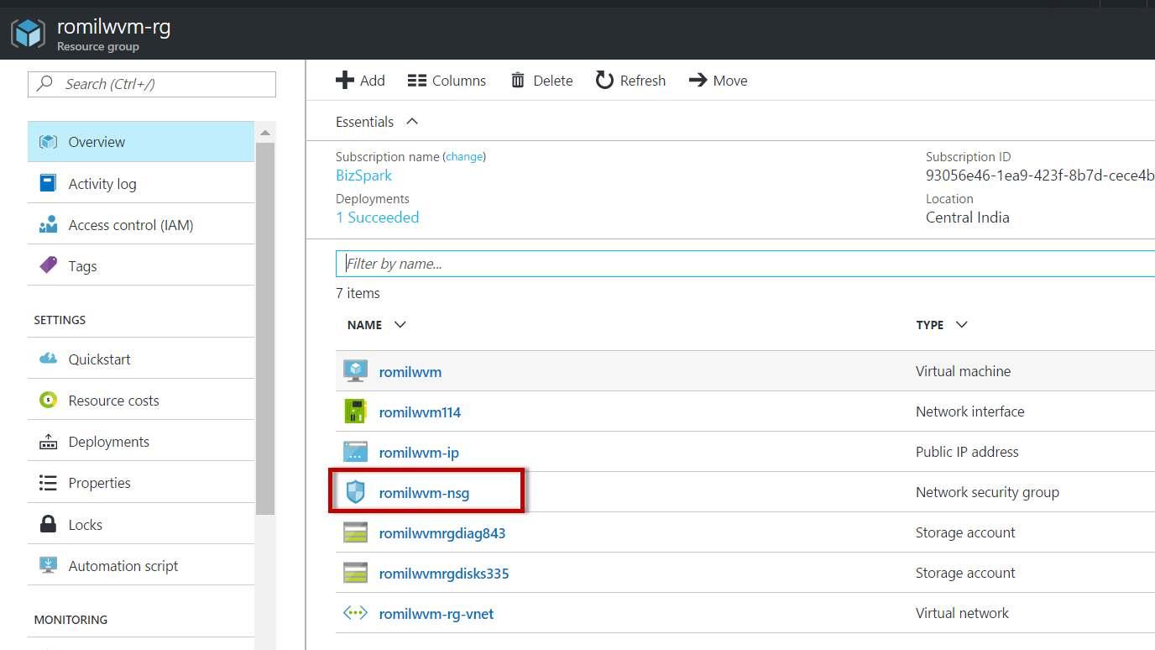

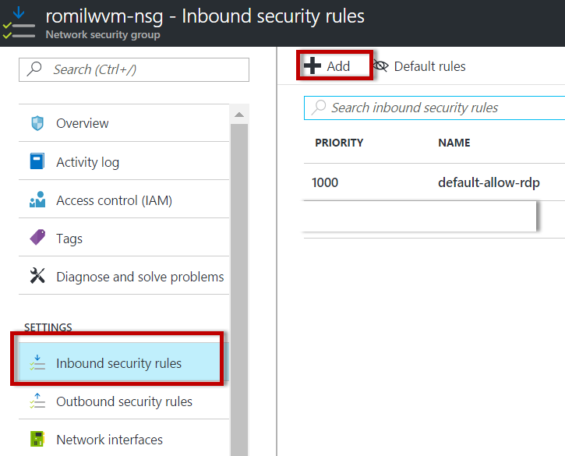

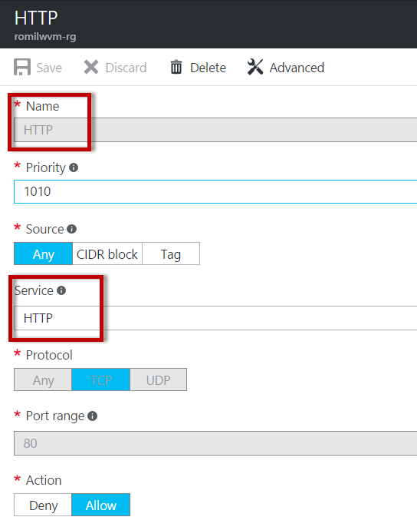

**Now navigate to VM public IP**

